A Brief History of the Modern Smartphone

Bri Mears

IS390: Reading and Research

06/01/2023

The smartphone is one of the most common pieces of technology today. Almost everyone owns and uses one. From 1994 to now, the smartphone has been an integral part of humanity’s daily life. The smartphone has gone through multiple iterations to get to the form factor that we recognize. Operating systems have come, gone, and improved upon themselves to create Android and iOS, which we know and love. Through different hardware, and software iterations, the smartphone has changed not just how society operates, but how different fields operate as well.

The definition of a smartphone is “a cell phone that includes additional software functions (such as email or an internet browser)” (“Smartphone Definition & Meaning.”). Under this definition, most people would think that the first smartphone was the iPhone, or a device that was released just before. This is false. The first smartphone was in fact the IBM Simon (See Fig. 1). The IBM Simon was a short lived device, only being on the market from 1994 to 1996, but it was the first device that used a touch capable screen, had applications that went beyond making and receiving phone calls. The IBM Simon was much different from the smartphones we know today, but it had a great influence on the smartphone and Portable Digital Assistant (PDA) market. PDAs (Personal Digital Assistants) were a significant influence on the development of smartphones.

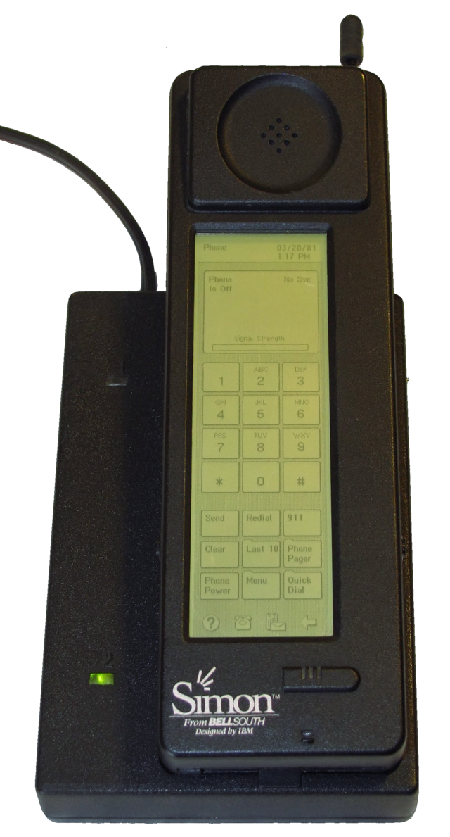

Fig. 1. Bcos47, *IBM Simon in Charging Case*, 2012

After PDAs came what is known as the ‘feature phone’. The feature phone was a phone that had the capability to play games, connect to the internet, and even take pictures. Often, the feature phone used a flip phone or sliding phone’s form factor. Unlike smartphones, once a feature phone had been shipped, the operating system could not be updated, and features could not be added. This differentiates the feature phone from the modern smartphone.

The Danger Hiptop, released in 2002, was the first "modern" smartphone with a touch screen, slide-out physical keyboard, and a store for downloading various applications. It was released under multiple names and was incredibly popular amongst consumers in the United States (Vance, 2009). In the US the Danger Hiptop was released as the T-Mobile Sidekick. It had a touch screen that slid up and down over a physical keyboard. It also featured a store where users could download various applications for the device, including Instant Messengers, email hosting services, and cloud backup software. The Hiptop’s primary challenger on the market at the time was Blackberry, another creator of phone/PDA hybrids. In fact, the Danger Hiptop was released just before Blackberry released what is commonly thought of as a Blackberry smartphone with the Blackberry 2 line of devices (Blackberry 7100, 7200, 7500, and 7700). Through 2011 the Danger Hiptop received several redesigns, some of which included color screens, the addition of MMS and 4G connectivity. The last unit to be produced under the Danger Hiptop brand was the T-Mobile Sidekick 4G in 2011.

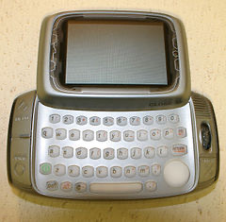

Fig. 2. David Mueller, *Color Model of the T-Mobile Sidekick*, 2005

There were smartphones released after the initial Danger Hiptop, but the most notable release during the 2000’s was of course the iPhone. The Apple iPhone was announced by Steve Jobs at a MacWorld conference on January 9th, 2007. The official press release refers to the iPhone as “a revolutionary and magical product that is literally five years ahead of any other mobile phone” (Jobs, 2007), and that it had a 3.5 inch screen, SMS messaging app, on-screen keyboard, auto-correct, syncable calendar, and visual voicemail. While (almost) all these features are standard on smartphones today, many of them were either pioneered in the iPhone, or improved upon to a point where consumers found it useful. This will be a reoccurring pattern for Apple and iOS devices.



The announcement of the iPhone was not exciting for everyone who heard it. In January 2007, Google was working on developing an operating system. The announcement of the iPhone undid everything the developers had been working on. They had been preparing for a release by the end of the year on what they thought would be a revolutionary device and operating system. Once they saw the iPhone’s announcement, they knew instantly that they would need to scrap everything and start over. Their project paled in comparison to what Apple had just revealed. What the team had been working on was “a phone code-named Sooner, [that] sported software that was arguably more revolu­tionary than what had just been revealed in the iPhone. In addition to having a full Internet browser, and running all of Google’s great web applications, such as search, Maps, and YouTube, the software was designed to not just run on Sooner, but on any smartphone, tablet, or other portable device not yet conceived.” (Vogelstein, 2013). This technology could have been revolutionary, but while the software was capable of competing with Apple’s iPhone, the hardware was not. “Sooner “looked like a Black-Berry, with a traditional keyboard and a small screen that wasn’t touch-enabled.” (Vogelstein, 2013) It also did not help that many Google executives were worried that if people used non-google devices to access the internet then those other companies would want to prioritize other search engines over Google. While companies like Microsoft couldn’t do this in computer operating systems due to anti-trust laws created in the 1990s there were no such laws governing what companies could do with internet enabled cell phones. Consequently, Sooner was scrapped and replaced with “…[a] phone with a touchscreen, code-named Dream, that had been in the early stages of development, became the focus. Its launch was pushed out a year until fall 2008. Engineers started drilling into it all the things the iPhone didn’t do to differentiate their phone when launch day did occur.” (Vogelstein, 2013). The only thing the Google engineers had on their side was the fact that they got to see how the iPhone’s launch went, and see what people liked and didn’t like. They were then able to modify Dream to fit better with what they thought consumers wanted.

While at one point in time phones were used simply to call other people, the usage of cell phones has greatly evolved over time.

Short Messaging Service (SMS) has been in use since 1992, when a man named Neil Papworth sent a message reading “Merry Christmas” from his computer to his friends phone. Little did he know how much this one message (and his use of SMS) would change telecommunications. A year later Nokia would add the first T9 keyboard (see figure 3) to one of its phones, creating the first phone capable of sending SMS messages. There was a catch, messages could only be sent and received between 2 individuals on the same network. This would remain the standard for several years. In 1997 Nokia would once again change the texting game, and add a QWERTY keyboard to the Nokia 9000i. This allowed for faster texting than a T9 keyboard and couldn’t have come at a better time, as two years later in 1999 SMS messages would be able to be sent and received cross networks. In 2002 more than 250 billion SMS messages were sent worldwide, showing just how much consumers liked the service. In 2007 the amount of sent SMS messages would outnumber the amount of placed phone calls (Gayomali, 2015). Texting has cemented itself as a form of media among cell phone consumers.

Fig. 3. Sakurambo, *Telephone keypad with letter mapping corresponding to the ITU E.161 standard*, 2007

As texting made itself popular amongst consumers, another form of communication started rising in popularity. Instant Messaging (IM) was first generally available in the 1980s, though it did not start to take off until the late 1990s with the introduction of services like AIM, Yahoo! Messenger, and MSN messenger. These services continued to grow in popularity as internet speeds increased. Some have even credited IMs growth in the early 2000s to the growing cost of sending and receiving text messages. Unlike SMS, one did not have to pay to send and receive IMs. This is thought to have helped IM services grow in popularity. In 2003, Skype launched, bring video calls into the feature set of the IM client. It was not the first to do this, but (like Apple with the iPhone) it was the first to do it well enough that the general populace took notice. In 2010 there was a decrease in IM usage, primarily due to the newfound popularity of services like Facebook and Twitter, as people moved their interactions to those platforms. However, this trend did not persist, as IM clients soon made their way onto smartphones. As stated before, SMS was more expensive than IM, and the ability to have IM clients on the smartphone, in place of sending SMS was enticing for most customers. By 2013 users of the IM client WeChat were sending around 30 billion messages every day, as opposed to the 20 million daily SMS messages.

Around the world people play video games on their smartphones, but mobile gaming is not smartphone exclusive. When one hears the term ‘Mobile Gaming’ they may think of games like Candy Crush, or Genshin Impact, but mobile gaming has been around for almost 30 years as of 2023. The first known mobile game was a Tetris clone that came pre-installed on a Danish cellphone called the Hagenuk MT-2000 in 1994. Soon consumers would be introduced to what is possibly the most well known mobile game in the 90s, Snake, which came preinstalled on Nokia cellphones starting in 1997. It came preinstalled and has since found its way onto over 350 million devices worldwide. With the launch of the iPhone more and more mobile games founds their way onto the market, and in 2012 the world would see the introduction of *Candy Crush* and *Puzzles and Dragons* which pioneered the Freemium game model. The Freemium model is a free to play game, where you can purchase add-ons to make the game easier or be able to play for longer. Mobile games have become incredibly popular among consumers, leading industry analysts to predict that gaming console sales would flop in the early 2010s. However, due to the differences in the type of games that gaming consoles play, and the type of games that people play on cell phones, this did not pan out, and both gaming consoles and mobile games are still going strong in terms of sales.

When the smartphone was introduced, using it to access the internet felt like an afterthought. Most webpages were not formatted in a smartphone friendly way, and most consumers did not want to continuously scroll just to read a news article. Data speeds at the time were also slow, and it took a while for webpages to load due to how much content was on them. Even if the page loaded, there was also no way to guarantee that the page would fully load, as many web plugins used at the time were not compatible with smartphones. None of this was user friendly, and as such, people were not as likely to use their phones to browse the web. However, as the number of smartphone users grew, companies started investing in mobile friendly websites, as users were more likely to stay on (and purchase things from) websites that were easy to navigate on a smartphone.

Another feature that has cemented itself in the smartphone is the camera. Smartphones gradually replaced digital cameras for most consumers (Wilson, 2022), starting with cell phone models like the Samsung SCH-V200 and Sanyo SCP-5300. The first phone to have a camera built into it was the SCH-V200 manufactured in 2000 by Samsung. However, unlike current smartphones, the SCH-V200 had a .35 megapixel camera, and needed to be plugged into a computer in order to retrieve your photos. However, the SCH-V200 never made it to the U.S. Instead, the first U.S phone to have a camera was the Sanyo SCP-5300 which released on Sprint’s network in 2002. It had a slightly worse camera (at .3 megapixels) despite being released 2 years after the SCH-V200. It also had a flash, basic photo timer, zoom, and some simple filters. Camera megapixels would increase to 1.3 MP in 2004 when spirt released the Audiovox PM8920. This phone also introduced multi-shot mode to camera phones (which allowed the PM8920 to quickly take up to 8 pictures in a row). 2005 would bring the Nokia N90, which introduced an LED flash, and autofocus, as well as a 2MP camera. 2007 would not only be the height of the feature phone, but would also see the first phones with 5MP cameras. While Samsung was technically the first manufacturer to release such a device, Nokia was the first to release a popular one. The Nokia N95 not only had a 5MP camera, but also was able to record video at 30 frames-per-second (FPS). For reference, the iPhone was released this same year, and only had a 2MP camera, and no video recording capability.

The next bit of cellphone camera history is a bit odd. While smartphones had hit the scene and were slowly gaining popularity, camera development was still happening in feature phones, while there was very little development happening in the smartphone. 2008 would bring the Samsung i8510 which had an 8MP camera. Samsung would beat themselves in the MP race in 2009 with the M8910 Pixon12 which boasted a 12MP camera. 2010 would find them outpaced by Nokia with the Nokia N8 (with a better quality 12MP camera, and both phones would be beaten by Sony with the launch of the Sony Ericsson S006 in late 2010 with a 16 MP camera. 2011 would bring a camera failure with HTC and LG trying to bring 3D technology into their 5MP cameras (See Fig. 3 for an example, the HTC Evo 3D). The *HTC One* would see a decent downgrade in camera tech, as HTC tried to cut costs with a 4MP camera. The Samsung Galaxy S4 Zoom (one of the high end, camera focused smartphones of the time) only had a 16MP camera in it, though it did boast an impressive optical zoom feature. 2013’s Nokia Lumia 1020 would take a huge leap in camera technology and include a 41MP camera (compared to the iPhone 5’s 8MP camera).

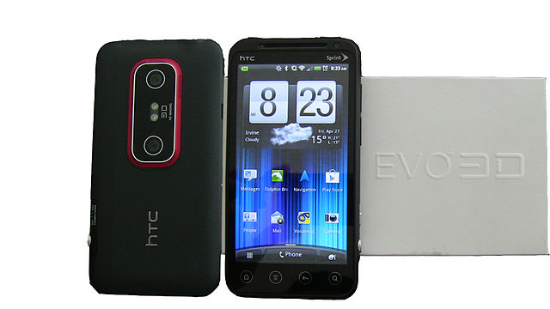

Fig. 4. Crazymouseftw, *HTC Evo 3D*, 2012

In 2016, Apple changed the smartphone camera game with the iPhone 7 Plus and its 2 rear cameras. Unlike the failed HTC 3D dual camera setup, Apple instead used the 2nd camera as a wide-view lens. The iPhone 7 Plus featured a 12 MP camera, and a 12MP telephoto camera, as well as the first smartphone portrait mode. Other smartphones have followed since, and now there are smartphones such as the Samsung Galaxy S12 Ultra, which feature 5 cameras on the rear of the phone.

Today, smartphones are ubiquitous and used in various applications. They are relatively cheap, reliable, and extremely portable compared to laptops. Smartphones have revolutionized various fields, from education to medicine to mechanics, providing cheap and portable access to information. Schools in low-income areas utilize smartphones to provide students with internet access and access to online educational materials (Arias, 2019). Often these schools do not have the funds to purchase computers for student use (or the only computers they can afford are practically unusable). However, most teenagers these days have a smartphone. The students know how to use their own devices, and teachers can have students use these devices instead of the older slower computers. This way students can access educational materials without having to use a slow laptop or crowd around a desktop computer in order to interact with an online textbook or watch a YouTube video. Smartphones have also been used to allow students and teachers to stay in communication. Even when data is expensive, smartphones can use IM clients like WeChat to aid teachers in grading student’s assignments, and giving them help while not in the classroom. Students can ask their teachers a question, all through the use of the internet and a smartphone.

As mentioned earlier, smartphones have changed how other fields operate, not just education. Libraries have started offering electronic copies of their books and audiobooks to their patrons, often through the use of an app. Car companies have created apps that can be used to see maintenance information about the vehicle, and remote start it. The Omnipod 5 system communicates with a mobile app to keep an individual informed of their current blood sugar levels, and allowing them to adjust insulin levels through the app. People can communicate with their doctors from an online portal, writing and sending messages to their doctor about various health issues that they may be having.

There are also changes in people’s behavior and usage of smartphones that is less important or urgent in its usage. Smartphones played a large role in the development and usage of the internet in the late 2000s. While laptops made the internet more mobile, smartphones made it more accessible to everyone. One of the world’s greatest resources was now in the palm of millions of people’s hands. Instead of having to go to a computer to look up the answer to a question, people could pull out their phone and google it right then and there. Entertainment is also easily accessible in the era of the smartphone. While before one would need to be seated in front of their television or computer (and would likely need a DVD or VHS copy of whatever they wanted to watch) now people can pull up youtube, social media, e-book reading applications, and a whole slew of video streaming services to keep them entertained when they are bored.

The smartphone is one of the most common pieces of technology today. Almost everyone owns and uses one. From 1994 to now the smartphone has been an integral part in humanities daily life. The smartphone has gone through multiple iterations to get to the form factor that we recognize, and has gone through multiple feature sets. Operating systems have come, gone, and improved upon themselves to get to the Android and iOS that we know and love. Through different hardware, and software iterations, the smartphone has changed not just how society operates, but how different fields operate as well.

Works Cited

Aamoth, Doug. “First Smartphone: Fun Facts about Simon.” Time, 18 Aug. 2014, time.com/3137005/first-smartphone-ibm-simon/.

“A Complete History of the Camera Phone.” Digital Trends, 11 Aug. 2013, www.digitaltrends.com/mobile/camera-phone-history/.

Arias, Raquel Londoño. “Will the Future Classrooms Regularly Use Cell Phones?” *The Discoverer*, thediscoverer.columbus.edu.co/opinion/will-the-future-classrooms-regularly-use-cell-phones/. Accessed 9 June 2023.

Bonavia, Miguel F. “The Rise of Messaging Platforms.” Medium, 10 Jan. 2018, chatbotnewsdaily.com/the-rise-of-messenger-platforms-and-its-legal-implications-62fe73355122.

Chan, Stephanie. “Mobile Game Revenue Finally Surpasses PC and Consoles.” VentureBeat, 13 July 2017, venturebeat.com/games/mobile-game-revenue-finally-surpasses-pc-and-consoles/.

Desjardins, Jeff. “The Evolution of Instant Messaging.” Visual Capitalist, 17 Nov. 2016, www.visualcapitalist.com/evolution-instant-messaging/.

Gayomali, Chris. “The Text Message Turns 20: A Brief History of Sms.” The Week, 8 Jan. 2015, theweek.com/articles/469869/text-message-turns-20-brief-history-sms.

Hall, Chris. “Dual, Triple, Quad, Penta Camera Smartphones: The History Running through to the Present Day.” Pocket, 7 Feb. 2022, www.pocket-lint.com/phones/news/samsung/138719-dual-triple-quad-penta-camera-smartphones/.

Hamilton, Ian. “Can Blackerry Torch Compete with Iphone?” Orange County Register, 21 Sept. 2010, www.ocregister.com/2010/09/21/can-blackerry-torch-compete-with-iphone/.

Kerris, Natalie. “Apple Reinvents the Phone with iPhone.” Apple Newsroom, 23 May 2023, www.apple.com/newsroom/2007/01/09Apple-Reinvents-the-Phone-with-iPhone/.

King, Ian. “Bendable Smartphones Aren’t Coming Anytime Soon.” The Sydney Morning Herald, 15 Dec. 2013, www.smh.com.au/technology/bendable-smartphones-arent-coming-anytime-soon-20131213-2zbtq.html.

Künzler, J. Glenn. “How Smartphones Are Killing the Point-and-Shoot Camera.” MacTrast, 26 Dec. 2011, www.mactrast.com/2011/12/how-smartphones-are-killing-the-point-and-shoot-camera/.

McDuling, John. “This Simple Pricing Strategy Has Driven the Phenomenal Growth of Mobile Gaming.” Quartz, 25 Mar. 2014, qz.com/191931/the-phenomenal-growth-of-the-mobile-games-industry-in-charts.

Mier Zhang, Haipeng Li, and Ximei Liu, "Technology Trend Study Based on Valid Patents of Smartphone Industry," Journal of Economics, Business and Management vol. 8, no. 2, pp. 133-138, 2020

Rose, Frank. “Pocket Monster.” Wired, 1 Sept. 2001, www.wired.com/2001/09/docomo/.

T., Nick. “This Was the World’s First Cell Phone with a Game Loaded on It.” Phone Arena, 17 Nov. 2014, www.phonearena.com/news/This-was-the-worlds-first-cell-phone-with-a-game-loaded-on-it_id62920.

Taylor, Petroc. “Mobile Network Subscriptions Worldwide 2028.” Statista, 30 Mar. 2023, www.statista.com/statistics/330695/number-of-smartphone-users-worldwide/.

“The History of Personal Digital Assistants 1980 - 2000.” Agile Mobility, web.archive.org/web/20131030153659/agilemobility.net/2009/04/the-history-of-personal-digital-assistants1/. Accessed 27 May 2023.

The Smartphone Annales Japanese Inventions and West- Ern Narratives ..., asiainfocus.dk/wp-content/uploads/2018/07/AIF_ISSUE6_Final-Sneep.pdf. Accessed 1 June 2023.

“Smartphone Definition & Meaning.” Merriam-Webster, www.merriam-webster.com/dictionary/smartphone. Accessed 27 May 2023.

“Simplify Life with Omnipod® 5.” Omnipod, www.omnipod.com/what-is-omnipod/omnipod-5. Accessed 27 May 2023.

Vance, Ashlee. “Some Users May Lose Data on a T-Mobile Smartphone.” *The New York Times*, 11 Oct. 2009, www.nytimes.com/2009/10/12/technology/business-computing/12sidekick.html

Vinton G. Cerf. 2022. How do I rely on thee, smartphone? Commun. ACM 65, 2 (February 2022), 7. https://doi.org/10.1145/3505589

Vogelstein, Fred. “The Day Google Had to ‘start over’ on Android.” The Atlantic, 19 Dec. 2013, www.theatlantic.com/technology/archive/2013/12/the-day-google-had-to-start-over-on-android/282479/.

Warren, Tom. “This Is Samsung’s Foldable Smartphone.” The Verge, 7 Nov. 2018, www.theverge.com/2018/11/7/18072514/samsung-foldable-phone-screen-features-photos-sdc-2018.

Welch, Chris. “Chat Apps Surpass SMS for the First Time, Study Finds.” The Verge, 29 Apr. 2013, www.theverge.com/2013/4/29/4281618/chat-apps-surpass-sms-messaging-volume-study.

Wilson, Mark. “Smartphones Will Kill off the DSLR within Three Years Says Sony.” *TechRadar*, 1 June 2022, www.techradar.com/news/smartphones-will-kill-off-the-dslr-within-three-years-says-sony.